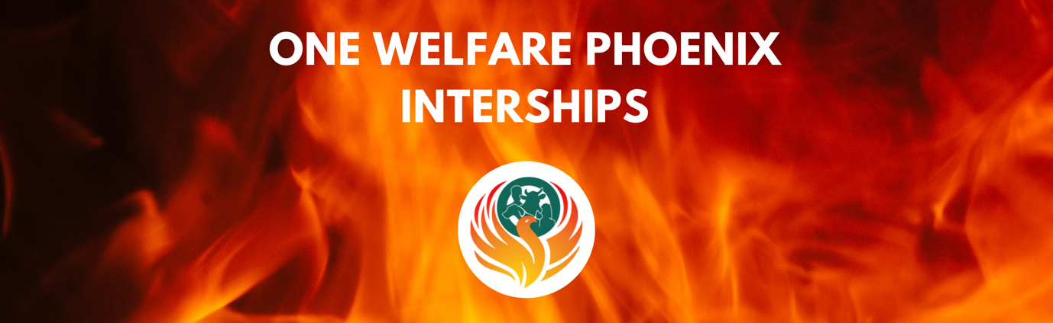
ROLE SPECIFICATION
Position: One Welfare Phoenix: Literature Reviewer (Working Groups)
Location: Remote working
Salary: Voluntary (if eligible you may apply for a UFAW Scholarship)
Commitment: Quarterly meetings (approx. 2hrs) + 10hrs max per month, flexible to suit
Reports: Working Group Leads
Eligibility: Only open to MSc and post-graduate students with a strong interest in policy making. If wishing to apply for more than one working group make reference to this on the application form.

Apply by: 3rd February 2023

Overall Purpose of the Role:

Exciting opportunities have arisen for volunteers to assist the four working groups that will support the remit of the One Welfare Phoenix Project. These volunteering opportunities will provide rich experience of contributing to research and policy development on an international scale.
The Volunteer will provide literature reviews on the topics identified by the working groups The workload and time commitment will be agreed between the volunteer and the working group Lead(s) on an individual basis. The expectation is that the time commitment will usually involve around 10 hours per month, in order to support meaningful progress.
The role includes an opportunity to help design and run subject matter workshops to support the literature review and evidence gathering.
There are four working groups, consisting of two leads and four or more members. The four working groups are
- companionship
- farming
- working animals and animals in entertainment
- free roaming
These working groups support the key priorities of the One Welfare Phoenix Project which are:
- to facilitate the exchange of information, experience and best practice in the area of animal and human abuse and neglect including the connections to the environment;
- to follow up, discuss, peer review and clear final drafts of the specific sub groups before they are released for wider consultation and before they are published;
- production and/or dissemination of other materials which could help understanding and increase awareness of programmes that address the links of abuse and neglect of humans, other animals and their physical and social environment;
- secure funds and resources for the development of the project including supporting and organising relevant seminars, workshops and the publication of guidance as necessary.
Key Responsibilities:

- Undertake relevant training, as identified by the Working Group leads in the relevant subject of that Working Group
- Participate in training/mentoring regarding the One Welfare Phoenix Project approach to literature reviews [regular mentoring will be available to suit both parties]
- Provide the Working Group with focussed, informative and insightful literature reviews
- Contribute to working groups that will provide evidence to the One Welfare Phoenix Project Board on a particular issue

Personal specification:
 | Desirable
Education & qualifications | - Currently hold or are working on a relevant under-graduate degree or post-graduate qualification
Experience & job knowledge | - Demonstrable experience of undertaking literature reviews  - Experience of handling and analysing research data
Job related skills / competencies | - Strong verbal and written communication skills  - Ability to deal confidently and confidentially with people internally and externally  - Attention to detail  - Ability to work to tight deadlines  - Calm under pressure  - Ability to evaluate and process detailed information  - Critical thinking  - Excellent communication skills  - Decision-making skills  - Open-mindedness  - Commitment
Personal attributes | - A strong interest in and commitment to animal  Welfare, and one welfare, in particular to the interconnection between animal and human abuse  - Team player  - Enjoys working in an international, multidisciplinary team  - The ability to handle challenging situations  - Act with professional integrity  - Caring and compassionate  - Flexible
Additional relevant criteria | - Willing and available to attend all relevant meetings and undertake required preparation such as reading and drafting of supporting documentation  - Access to academic tutor, laptop/internet/, library/e-library and literature review software

One Welfare Phoenix 2023
LITERATURE REVIEWER SUGGESTED GUIDANCE

Useful links
Finding resources: https://libguides.library.cityu.edu.hk/litreview/evaluating-sources
What is a literature review: guide, template and examples: https://www.scribbr.co.uk/thesis-dissertation/literature-review/
Suggested guidance to undertake a literature review:
Accuracy, authority, objectivity, currency and coverage are the five basic criteria for evaluating information from any source.

 | Questions to ask:
Accuracy | - Is the information reliable?  - Is the information error-free?  - Is the information based on proven facts?  - Can the information be verified against other reliable sources?
Authority | - Who is the author?  - Does he or she have the qualifications to speak/ write on that topic?  - Is the author affiliated with a reputable university or organisation in this subject field?
Objectivity | - What is the intended purpose of the information?  - Is the information facts or opinions?  - Is the information biased?
Currency | - When was the information published?  - Is the information current or out-dated?  - Does currency matter in this topic?
Coverage | - Does the information covered meet your information needs?  - Does it provide basic or in-depth coverage?
Conducting a literature review involves collecting, evaluating and analysing publications (such as books and journal articles) that relate to the topic you are looking at. Steps to take when conducting a literature review includes the following:
- As a group identify and agree on the keywords you will use to search for articles relating to your topic
- As a group choose at least two people who will be responsible for conducting this initial literature review or will help support interpretation of what the Literature Reviewer Volunteers provide.
- Whoever has been tasked with conducting the literature review should enter the agreed keywords into https://www.open.ac.uk/library/ as this is a great toolkit for finding research articles and papers.
- Run a search with each keyword and record how many articles and papers are found.
- Start looking at the most recently published articles and research papers as you will find that they often reference more historical papers that will turn up in your search history.
- Look at just abstracts initially and make a note of any articles, papers that you feel would be of benefit reading the full paper. If you do not have access to the full article or research paper, we can seek support from our university contacts and ask them to pass the relevant paper on to us.
- Record your literature review findings in a spreadsheet which summarises the title of the article or paper, the author, date of publication, where it is located (i.e. in a journal, in a book, magazine etc), key findings and whether access to the full article or paper is required for the group to read.
- Ensure that a shared folder has been established so all members of the committee can view the spreadsheet and access the relevant articles and papers that have been selected for in depth review.
- Set time aside for all members of the group to read all papers and then arrange a meeting to discuss the findings.
- Once you all discuss and agree findings you can proceed to prepare a paper and submit it for review within the working group and thereafter to the One Welfare Phoenix advisory board for review and final clearance. The structure of the paper should usually include the following (suitable adjustments might be made for publication purposes if you wish to publish the review in a journal):

- Introduction and background – Introduce the topic
- Methodology – explains how the literature review has been conducted
- Discussion from Literature Review – Confirms how the literature review was conducted, key findings that was similar across all relevant articles and papers, highlights any research gaps and confirms evidence that has been used to inform the recommendations.
- Results – Summarises the steps taken to review the ethical considerations in relation to this topic and includes tables and charts which highlight the findings from discussions that took place and indicates any difficulties that have occurred in reaching a decision. Also reflects on how these decisions link with the Society’s values and principles.
- Recommendations – Recommended highlights for potential implementation/guidance, evidence gaps for further research.
- Review – Highlights a time frame as to when the available evidence should be reviewed. (i.e. There may be awareness of research that is ongoing but has not yet been published which would influence the results that have been drafted.)

